DC Sustainable Energy Utility Advisory Board (DCSEUAB) Meeting
Tuesday, March 12, 2024
10:00 AM – 12:00 PM

Call to Order
Chair Jamal Lewis called the meeting to order at 10:08 AM, March 12, 2024. Chair Lewis called a quorum of the Sustainable Energy Utility Advisory Board (SEUAB or Board) at 10:10 AM. This was a Microsoft Teams video conference call meeting.

Roll Call/Instructions
Roll call was taken at 10:08 AM and the following people were in attendance:

Board Members
Name | In Attendance? | FY 2024 Special Meetings  Attendance Record | FY 2024 Committee Meetings Attendance Record | FY 2024 Regular Meetings  Attendance Record
Jamal Lewis - Board Chair (Mayor’s Designee) | Yes | 1/1 | 1/4 | 6/6
Mansi Talwar (Councilmember Allen) | Yes | 1/1 | 2/4 | 4/6
Sandra Mattavous-Frye (or OPC proxy) | Yes | 1/1 | 4/4 | 5/6
Danielle Gurkin (PSC) | Yes | 0/1 | 1/4 | 3/6
Pending - (Electric Company) | N/A | N/A | N/A | N/A
Eric Jones (Building Management) | Yes | 0/1 | 4/4 | 6/6
Nina Dodge (Environment) | Yes | 1/1 | 1/4 | 6/6
Pending (Low-Income Community) | N/A | N/A | N/A | N/A
Jaleel Shujath (Economic Development) | Yes | 1/1 | 2/4 | 6/6
Sasha Srivastava (Renewable Energy) | Yes | 1/1 | 3/4 | 6/6
Giuls Kunkel (Building Construction) | Yes | 1/1 | 2/4 | 4/6
Dr. Larry Martin – Vice Chair (Council Chairperson Mendelson) | Yes | 1/1 | 3/4 | 6/6
Pending – (Gas Utility) | N/A | N/A | N/A | N/A

Other Attendees: Gleniss V. Brown Wade (DCSEU), Angela Johnson (DCSEU), Ernest Jolly (DCSEU), Crystal McDonald (DCSEU), Jahmai Sharp (DCSEU), Solome Girme (DCSEU), Jennifer Johnston (DOEE), Dr. Lance Loncke (DOEE), Hussain Karim (DOEE), Brent Peterson (DOEE), Dr. Yohannes Mariam (OPC), Kintéshia Scott (OPC), Adam Carlesco (OPC), Nicholas Weil (BEGA)

Announcement of New Chair
- Jennifer Johnston (DOEE) opened the meeting by thanking Vice Chair Dr. Larry Martin for his leadership during the past 6 months of transition. Vice Chair Dr. Martin not only lead the Board’s monthly meetings since November 2023, but also lead the Board’s Public Service Commission subcommittee and provided testimony on behalf of the Board during DOEE’s/DCSEU’s oversight hearing.
- Nina Dodge motioned to recognize Dr. Martin’s contribution to the Board in the meeting minutes and was seconded by Danielle. All were in favor, none were opposed.
- Jennifer Johnston (DOEE) shared the Mayor’s executive order naming Jamal Lewis as the Board’s new Chair.
- Chair Jamal Lewis thanked Vice Chair Dr. Larry Martin for his leadership and continued commitment to the DCSEU. Chair Lewis shared his excitement to be working with the Board in this new capacity and continuing to support the DCSEU in its great work.
- Director Jolly highlighted his appreciation for Vice Chair Dr. Martin and the new Chair.

Approval of Agenda
- Chair Jamal Lewis moved to approve the agenda. All were in favor, and none were opposed.

Approval of February Minutes
- Nina Dodge moved to approve the February meeting minutes and was seconded by Vice Chair Dr. Larry Martin. All were in favor, none were opposed.

DCSEU FY24 Q1 Workforce Development Update
- Crystal McDonald and Gleniss V. Brown Wade (DCSEU) presented on DCSEU’s FY24 Q1 workforce development:
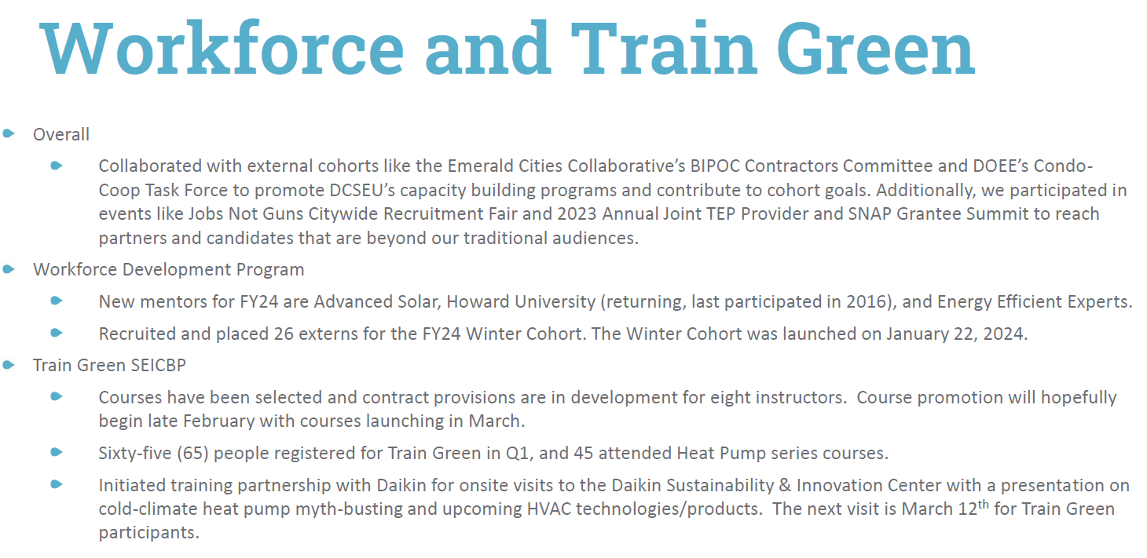
- Eric Jones asked:
  - Is the DCSEU workforce team taking part in the Office of the Deputy Mayor for Planning and Economic Development’s (DMPED’s) March Madness event this week?
- Crystal McDonald (DCSEU) shared that the DCSEU’s events are managed by the marketing team and that team has a full calendar of events. Crystal mentioned she would double check on the DMPED March madness event and see whether the DCSEU is participating.
- Nina Dodge asked:
  - What does TEP stand for?
- Eric Jones answered:
  - TEP is the TANF Employment Program, which is the employment program for those who qualify for TANF, which is Temporary Assistance for Needy Families (TANF).
- Nina Dodge asked:
  - Is the DCSEU participating in the Healthy Homes Fair occurring on April 6th?
- Jennifer Johnston highlighted that the DCSEU is a sponsor of the Healthy Homes Fair.
- Nina Dodge asked:
  - Is the DCSEU working with any local Unions on workforce development?
- Crystal McDonald (DCSEU) mentioned that the team has started conversations with UDC and IBEW Local 26.
- Eric Jones shared that if the group wanted to talk about diversity, equity and inclusion, it would be helpful to have conversations with the Department of Employment Services and the organizations that oversee the work of apprentices. Because if we just focus on unions, most DC residents will be left out, especially considering IBEW Local 26 is based out of Southern Maryland.

PSC Committee Updates
- Vice Chair Dr. Larry Martin shared that he would draft the Board’s comments on the VDER Study to the PSC. He mentioned that the OPC team, Eric Jones, and Mansi Talwar offered to review the draft comments before sharing with the larger Board.
  - Jennifer Johnston (DOEE) agreed to edit and finalize the Boards comments. Jennfier will work with Hussain Karim (DOEE) to submit the Boards comments after Board vote.

Legislative Updates
- Hussain Karim (DOEE) shared that the Healthy Homes and Residential Electrification Amendment Act of 2024 had a bill markup on March 4th. Also, in late February, the PSC approved a one-year extension of PROJECTPipes for Washington Gas, the District government, OPC, and advocates opposed that extension. Additionally, Pepco's multiyear rate plan is still proceeding.
- Danielle Gurkin (PSC) mentioned that the PSC is holding three community hearings on Pepco's multiyear rate plan taking place on March 27th, April 2nd, and April 3rd.

New Business
- Eric Jones mentioned that there was a 90 day extension to the implementation of the Building Energy Performance Standards (BEPS) which was at the request to the mayor. Additionally, the Committee on Transportation and the Environment marked the new deadline for benchmark and third-party verification from April 1st to July 1st of this year.
- Nina Dodge moved to approve the addition of New Business to the agenda and was seconded by Vice Chair Dr. Larry Martin. All were in favor, none were opposed.
- Jennifer Johnston (DOEE) made a few announcements:
  - The Board monthly calendar invite will be resent to all participants (current invite only goes until June of this year)
  - March 18: Public hearing on 5 new bills

Follow up Items
- Crystal McDonald (DCSEU) to check-in with comms team on the DCSEU the Office of the Deputy Mayor for Planning and Economic Development’s (DMPED’s) March Madness event.
- Vice Chair Dr. Larry Martin to draft Synapse’s VDER Study Board comments for discussion.
  - The OPC team, Eric Jones, and Mansi Talwar to review the draft comments before sharing with the larger Board.
  - Jennifer Johnston (DOEE) to edit and finalize the Boards comments. Jennfier to work with Hussain Karim (DOEE) to submit the Boards comments after Board vote.

Board Action Items
- Approval of Meeting Agenda
- Approval of February Minutes
- Approval to include recognition for Dr. Martin in the minutes
- Approval to include New Business on future agendas

Future Agenda Items
- Approval of March Meeting Minutes
- PSC Letter Committee Update
- Legislative Updates
- New Business

Adjournment
- Chair Jamal Lewis adjourned the meeting at 10:50 AM.

Acronyms used during this meeting
- AHRA - Affordable Housing Retrofit Accelerator
- ATO - Authorization to Operate
- BSA - Bill Stabilization Adjustment
- CAEA - Clean and Affordable Energy Act of 2008
- CBE - Certified Business Enterprise
- CEM - Certified Energy Manager
- CREF - Clean Renewable Energy Facility
- DCSEU - District of Columbia Sustainability Energy Utility
- DERMS - Distributed Energy Resource Management Systems
- DOB – Department of Buildings
- DOEE - Department of Energy and Environment
- DSLBD - DC Department of Small & Local Business Development
- EEDR – Energy Efficiency and Demand Response
- kW - kilowatt
- MOTA – Mayor's Office of Talent and Appointments
- OPC - Office of the People’s Counsel
- PP2 - PROJECTPipes 2
- PSC - Public Service Commission
- SBCT - Societal Benefit Cost Test
- SEICBP - Sustainable Energy Infrastructure Capacity Building and Pipeline Program
- SETF - Sustainable Energy Trust Fund
- TAG - Technical Advisory Groups
- VPP - Virtual Power Plant
- WGL – Washington Gas Light
Minutes prepared by Jennifer Johnston, DOEE

